**Unit 2: Using Objects**

**Topic 2 Lab 1: Overloaded Constructors & Getters/Setters**

|  |  |
| --- | --- |
| **Name:** |  |

|  |  |
| --- | --- |
| **1.** Create a new IntelliJ project and name it LASTNAMEU2T1Lab1 (or whatever you want).  **2.** Create a new Rectangle class and copy/paste [**this code**](https://docs.google.com/document/d/1IAIGe1356v4Do7QWFTbNcCk0X6VBKUcDOiUJ0MBuycQ/edit?usp=sharing).  **3.** Create a RectangleRunner class and add a main method. | |
| How many *constructors* does the Rectangle class have?  How can you *tell* just by looking at a method that it's a constructor? | Confirm |
| **4.**  In the RectangleRunner class, create three Rectangle objects to represent three different plots of farmland, described below. Name the variables plot1, plot2, plot3   * plot1: a plot with a length of 150 and width of 200 -- use the constructor with two parameters * plot2: a square plot with side length 125 -- use the constructor with one parameter * plot3: a plot that has "default" values -- use the constructor with *no* parameters   **5.** Then, using appropriate Rectangle methods, write code in your runner class to print out the length, width, and area of each rectangle, like the following; do **not** modify the Rectangle class. You will need to use the "getter" methods (note that "getter" methods *return* values). **Using "getter" methods is generally how a client directly accesses (reads) the values of an object's instance variables (i.e. its stored data).**   After you type it up yourself, you can compare your code with this sample if you want.  |  |  | | --- | --- | | Why does plot2 have length and width *both* set to 125?  Why does plot3 have length and width set to 100 and 50? | check |   **6.** *Under* the print statements you typed above,write code to **update** all three plot *widths* to be 75. For plot2 (the square plot), *also* update its *length* to 75 to keep it a square. You will need to use the "setter" methods (note that "setter" methods are **void** methods). confirm **7.** Copy all the print statements you typed for step 5 and paste them below the code you just typed, so that you can see the *updated* values printed! **Using "setter" methods is generally how a client directly updates the values of an object's instance variables (i.e. its stored data).** confirm **8.**  Once you see how getters and setters are used, you can remove all the print statements (leave the code from step 6).  **9.** Now, assume you need to purchase grass seed to plant grass on all three plots. Write some code to calculate the total area of all three plots, and print it out:   confirm | |
| **Copy/paste your entire RectangleRunner class code below:** sample | |

**Lab continues on next page**

|  |  |
| --- | --- |
| **10.** Two of these code segments *will* successfully create objects from the Rectangle class but one *will not*. Which one will not, and why? (*hint*: inspect the constructors… it has to do with data types!)   1. int len = 65;   int wid = len + 10;  Rectangle rect = new Rectangle(len, wid);   1. Rectangle rect = new Rectangle(10.0, 30.0); 2. Rectangle rect = new Rectangle(0); | **My answer:** |
| **11. TEST!** Comment out your code in RectangleRunner andtest your answer above by copying/pasting/running the following code segment:  int len = 65;  int wid = len + 10;  Rectangle rect1 = new Rectangle(len, wid);  Rectangle rect2 = new Rectangle(10.0, 30.0);  Rectangle rect3 = new Rectangle(0); | After running the code, was your answer above correct?  What does the error indicate? Is it a compiler/syntax (red squiggly) error or a runtime error? *Confirm* |

**Lab continues on next page**

|  |  |
| --- | --- |
| **Boxes!** | |
| Below is a Box class. Note that the method allSidesLongerThan(int side) utilizes **Boolean** logic; in Java, the **||** operator is the **OR** operator (we will talk more about Booleans in Unit 3).  public class Box  {  private double length;  private double width;  private double height;  public Box(double length, double width, double height)  {  this.length = length;  this.width = width;  this.height = height;  }  public Box(double side)  {  length = side;  width = side;  height = side;  }  public double volume()  {  return length * width * height;  }  public boolean anySideLongerThan(int side)  {  if (length > side || width > side || height > side)  {  return true;  }  else  {  return false;  }  }  public void printDimensions()  {  System.out.println("L = " + length + ", W = " + width + ", H = " + height);  }  } | |
| **13.** How many *constructors* does the Box class have? | Confirm |
| **14. Predict, using just your brains!**  Determine which of the following statements *will* create a new Box object, and which will *not,* causing compiler errors (*hint:* look carefully at the Box constructor’s parameters)   1. Box box = new Box(5.0, 4.5, 7.2); 2. Box box = new Box(5, 4, 7); 3. Box cube = new Box(15.0); 4. Box cube = new Box(15); 5. Box box = new Box(2.5, 6.7); 6. Box box = new Box(); | **PREDICTIONS**  Will it create a Box object, or will an error occur? If an error will occur, why?  A)  B)  C)  D)  E)  F) |
| **TEST!**  1**5.** Create a new Box class and copy/paste the Box class code from above.  **16.** Create a new BoxRunner class with a main method, and copy/paste the following into it; fix the indentations to look nice 😎  Box box = new Box(5.0, 4.5, 7.2);  Box box = new Box(5, 4, 7);  Box cube = new Box(15.0);  Box cube = new Box(15);  Box box = new Box(2.5, 6.7);  Box box = new Box();  **17. *You can’t declare more than one variable with the same name*,** so rename all the box variables as box1, box2, box3, box4 and the cube variables as cube1, cube2. What should my code look like? **18.** Run the code to see which lines produce errors! Read the error messages; do they make sense to you? *Comment out those lines of code* and try running it again -- once you have commented out all broken lines, the program should run without error. **Confirm your predictions by comparing the incorrect (commented out) lines to your predictions!** | |
| **19. Were your predictions correct?**  If not, what mistake(s) did you make? | Confirm |
| **20.** Assume a Box object newBox has been properly declared and initialized as part of a client class as follows:  Box newBox = new Box(6, 10, 8);  Which of the following statements, labeled A - G, are *valid* and will compile/execute without error, and which *will lead to errors*?  double larger = newBox.anySideLongerThan(10); **// A**  boolean big = newBox.anySideLongerThan(7.5); **// B**  boolean x = newBox.anySideLongerThan(5); **// C**  String dim = newBox.printDimensions(); **// D**  System.out.println(newBox.printDimensions()); **// E**  newBox.printDimensions(); **// F**  double volume = newBox.volume(21.8); **// G** | ***Categorize each statement by putting an* X *in the appropriate column:***   |  |  |  | | --- | --- | --- | |  | **Valid (will work):** | **Will lead to an error:** | | A |  |  | | B |  |  | | C |  |  | | D |  |  | | E |  |  | | F |  |  | | G |  |  | |
| **TEST!**  **21.** In your BoxRunner class, copy and paste this: Box newBox = new Box(6, 10, 8);  **22.** Then, copy and paste the code above. Run it to see what happens! If any of your predictions was incorrect, be sure to read the explanations: Explanations | |
| **23.** The developer of the Box class wants to add the following method, printVolume(), to the Box class that prints the volume. The developer wants to use the already existing volume() method in the new printVolume() method.  public void printVolume() {  System.out.println("Volume = " + ________);  } | |
| Which one of the following could the developer type in the space?   1. volume 2. volume() 3. volume(length, width, height) 4. Box.volume() 5. None of the above | **ANSWER:** |
| **24. You guessed it! TEST** by copying/pasting the printVolume() method to your Box class and completing it as you believe it should be written, based on your answer to 23. Then, add a line of code in your BoxRunner class to test the new method on your newBox object.  Does it work? If so, your answer to 23 above was correct! If not, figure out your mistake! Confirm answer and test code | |

|  |
| --- |
| Time to write your first class! 😎  Have fun with this and challenge yourself! This is the first time you are writing a complete class, and it may seem crazy at first, but don't fret -- we will be talking in much more detail in the coming weeks about how to design classes. *But see what you can come up with here!* |
| Review how the Rectangle class was set up!  Now create and write a complete Point class that has:   * two int instance variables named x and y (be sure to make them **private**!) * a constructor that accepts and sets both instance variables   + If you also name your parameters x and y, be sure to use the this keyword! * a constructor that accepts one value and sets *both* x and y to the *same* value * a constructor that has no parameters and sets x and y to 0 (the origin) * a "getter" method for x, name it getX (it should return an int) * a "getter" method for y, name it getY (it should return an int) * a "setter" method for x, name it setX (it should be a void method and have an int parameter)   + name the parameter newX (as is typical) * a "setter" method for y, name it setY (it should be a void method and have an int parameter)   + name the parameter newY (as is typical) * a method named coordinate that has no parameters and returns the x and y value as a String coordinate in this format: "(5, 8)" * a method named quadrant that has no parameters and returns as a String the quadrant the point is in, either "I", "II", "III", "IV", "origin", or "on an axis"   + **TIP!**  For this, you might want to use AND logic, which we haven't learned yet but in Java the "and operator" is this: &&     - For example: if (x < 0 && y > 0)     - Another example: if (x == 0 && y < 0)   + **TIP 2:**  using an if statement with multiple else if branches and an else could also be helpful!   As a reminder, here are the quadrants:    **Write the complete Point class!**  **TESTING: When you are ready to test your class, copy/paste the following code into a new PointTester class:**  public class PointTester {  public static void main(String[] args) {  System.out.println("-- TESTING CONSTRUCTORS AND GETTER METHODS --");  Point p1 = new Point(10, 5);  System.out.println(p1.getX());  System.out.println(p1.getY());  Point p2 = new Point(12);  System.out.println(p2.getX());  System.out.println(p2.getY());  Point p3 = new Point();  System.out.println(p3.getX());  System.out.println(p3.getY());  System.out.println("-- TESTING SETTER, COORDINATE, QUADRANT METHODS --");  System.out.println(p1.coordinate());  System.out.println(p1.quadrant());  p1.setX(-8);  System.out.println(p1.coordinate());  System.out.println(p1.quadrant());  p1.setY(-14);  System.out.println(p1.coordinate());  System.out.println(p1.quadrant());  p1.setX(7);  System.out.println(p1.coordinate());  System.out.println(p1.quadrant());  p1.setX(0);  System.out.println(p1.coordinate());  System.out.println(p1.quadrant());  p1.setY(0);  System.out.println(p1.coordinate());  System.out.println(p1.quadrant());  p1.setX(13);  System.out.println(p1.coordinate());  System.out.println(p1.quadrant());  }  }  **RUN IT AND SEE IF YOUR CODE PRODUCES THE FOLLOWING OUTPUT EXACTLY:**      **Copy/paste your Point class below:**   |  | | --- | |  |  sample solution |

**Done!**

Submit in Google Classroom:



### Confirm code (back)

Your code should look something like this.

Note the use of the "getLength" and "getWidth" getter methods, which *return* **int** values

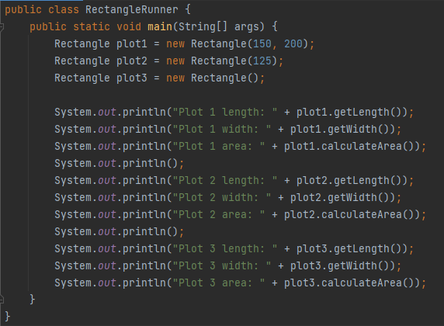

### Confirm (back)

You could do it like this:

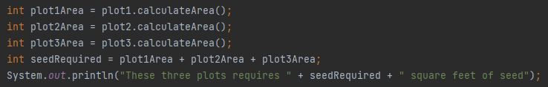

Or like this:



### Confirm (back)

|  |  |
| --- | --- |
| How many *constructors* does the Rectangle class have?  How can you *tell* just by looking at a method that it's a constructor? | **3** constructors (so this class has “**overloaded**” constructors because there is more than one!)  You can tell a method is a constructor because it has the exact same name as the class (in this case, Rectangle): |



### Check (back)

|  |  |
| --- | --- |
| Why does plot2 have length and width *both* set to 125?  Why does plot3 have length and width set to 100 and 50? | Creating plot 2 looks like this:    using one parameter, which corresponds to the one-parameter constructor in the Rectangle class:    In this constructor, both the length and width instance variables get set to the value passed in, which was 125  ---------------------------------------------------------------------------  Creating plot 3 looks like this:    using no parameters, which corresponds to the no-parameter constructor in the Rectangle class:    In this constructor, the length is set to a "default" value of 100 and the width is set to a "default" value of 50 |

### Confirm (back)

Use the "setter" methods -- note that those methods are "void" methods (so we just call them):



### Confirm (back)

Your code (yes, it's long!) should look something like this:

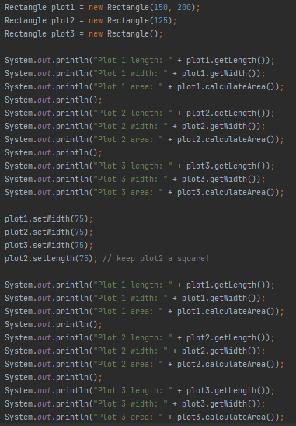

And when you run it, you should see the original values first printed, **THEN** the updated values!



### Sample (back)

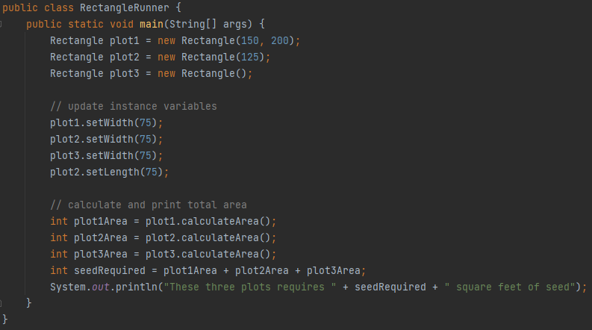

### Answer (back)

### 

**II will NOT compile**, and there is a **compile-time/syntax** error that shows you:

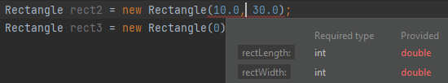

**When you try to run it away, we see Java yell:**



That is because the constructor public Rectangle(int rectLength, int rectWidth)is expecting two ***integers***, and the arguments being passed in are both *doubles*, so the compiler gives an error.

1. int len = 65;

int wid = len + 10;

Rectangle rect = new Rectangle(len, wid);

1. **Rectangle rect = new Rectangle(10.0, 30.0); // will NOT compile**
2. Rectangle rect = new Rectangle(0);

I **will** work because len = 65 (an integer) and wid = 75 (an integer), so the types match this constructor: public Rectangle(int rectLength, int rectWidth)

III **will** also work because new Rectangle(0) is a valid use of the single-parameter “square” constructor; even though passing 0 will give you a Rectangle with length and width being 0, it is still valid to do this.

### Confirm (back)

**Two** constructors (so this class has “**overloaded**” constructors because there is more than one); *reminder that a constructor has the same name as the* ***class*** *itself:*

public **Box**  matches public class **Box**

One constructor has three parameters, and one has one parameter:



### Check (back)

Note that the variables are all renamed to avoid duplicate variable names (which isn’t allowed in Java!):

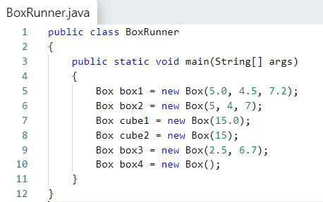

### Confirm (back)

|  |  |
| --- | --- |
| Determine if each of the following statements *will* create a new Box object *without* causing a compiler error:   1. Box box = new Box(5.0, 4.5, 7.2); 2. Box box = new Box(5, 4, 7); 3. Box cube = new Box(15.0); 4. Box cube = new Box(15); 5. Box box = new Box(2.5, 6.7); 6. Box box = new Box(); | **Will it work?**  **If an error will occur, why?**  A) **Yes**, it correctly uses the  public Box(double l, double w, double h) constructor  B) **Yes,** even though the constructor asks for doubles, Java auto converts int to double and so it uses the public Box(double l, double w, double h) constructor  C) **Yes**, it correctly uses the  public Box(double s) constructor  D) **Yes**, it uses the  public Box(double s) constructor in the same was as explained in B  E) **No**, an error will occur because there is no constructor with two double parameters.  F) **No**, an error will occur because there is no constructor with no parameters (unlike the Rectangle class from earlier, which *did* have a no-parameter constructor) |

### Explanations (back)

A. double larger = newBox.anySideLongerThan(10); **WILL LEAD TO ERROR!**

The anySideLongerThan(int) method returns a **boolean** value, and this statement is attempting to store the return value as a double. This will result in a compiler error.

B. boolean big = newBox.anySideLongerThan(7.5); **WILL LEAD TO ERROR!**

The anySideLongerThan(int) method accepts an int value, and this statement is attempting to pass a double value in the parameter. Although Java is able to convert an int parameter to a double (as you saw in the previous problem), it **cannot** convert from a double to an int. This will result in a compiler error.

C. boolean x = newBox.anySideLongerThan(5); **VALID (WILL WORK)!**

The anySideLongerThan(int) method accepts an int value, and an int value is being passed, and the method returns a boolean value, and x is properly declared as boolean.

D. String dim = newBox.printDimensions(); **WILL LEAD TO ERROR!**

The printDimensions() method is a void method (no return value), and this statement attempts to store a return value in the String variable dim, which you cannot do if the method returns no value! This will result in a compiler error.

E. System.out.println(newBox.printDimensions()); **WILL LEAD TO ERROR!**

The printDimensions() method is a void method (no return value), and this statement seems to assume the method returns a String return value, which is not true; therefore, trying to print the result of the method is not appropriate. This will result in a compiler error.

F. newBox.printDimensions(); **VALID (WILL WORK)!**

The printDimensions() method is a void method (no return value), and void methods are intended to be invoked by simply calling the method, as is done here.

G. double volume = newBox.volume(21.8); **WILL LEAD TO ERROR!**

The volume() method’s signature does not include a parameter, and this statement is inappropriately providing a parameter. This will result in a compiler error. Note that if the 21.8 was removed, the statement *would* then be valid: double volume = newBox.volume();

### Answer (back)

|  |  |
| --- | --- |
| The developer of the Box class wants to add the following method, printVolume(), to the Box class that prints the volume for the client. The developer wants to use the double() method in the new printVolume() method.  public void printVolume()  {  System.out.println("Volume = " + ________);  }  Which *one* of the following should the developer type in the space?   1. volume 2. **volume()** 3. volume(length, width, height) 4. Box.volume() 5. None of the above | **The answer is B**  **volume() is how the developer would call the class’ volume method as part of a print statement.**  **See below for the full statement.** |

**Test code statement in your BoxRunner class:**

**newBox.printVolume(); // note that printVolume is a VOID method!**

### Sample solution (back)

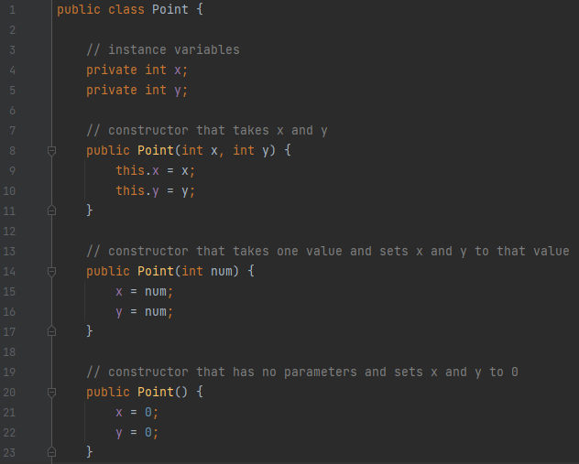

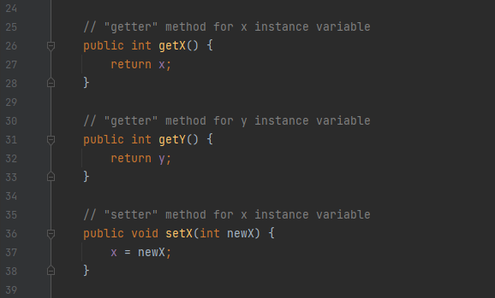

**// continued on the next page**

